NEW VENUE NEW EVENT!
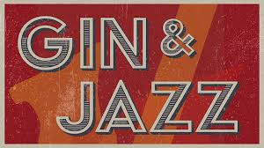
AT ROWLEY MANOR
Come and join us for a fabulous evening at Rowley Manor
Saturday 14th October 2023, 7.30 for 8pm
£37.50 per person
to include a choice of gin and mixer or glass of wine on arrival,
2 course meal with coffee and great jazz entertainment!
Please note:
Places must be booked early for this event … by Monday 4th September 2023
…………………………………………………………………………………………………………………………………
Booking Slip for Gin and Jazz on Saturday 14th October 2023
I wish to book …… places/s at £37.50 each

I cannot attend but enclose a donation/ have donated by BACS

I enclose a cheque for £……… made payable to “B.H.C.A.”

I confirm I have paid £…… by BACS. Please use your last name followed by “GJ” as the reference

Sort Code: 56-00-06 Account Number: 13301853

Name
Address

Telephone email:

Please return, with your payment by Monday 4th September 2023 to:
Beverley and Holderness Conservatives, 9 Cross Street, Beverley, HU17 9AX

