THE 2nd GREAT HOG ROAST EVENT
AT WASSAND HALL
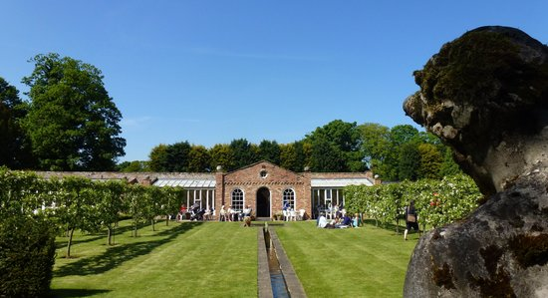
Come and join us for a fabulous Hog Roast in the beautiful gardens of
Wassand Hall, Seaton HU11 5RJ
Friday 7th July 2023 from 7pm
(by kind invitation of Mr and Mrs R Russell)
£29.50 per person
to include first glass of wine, hog roast with all the trimmings and assorted salads, followed by a choice of homemade puddings.
Pre-ordered Veggie option available.
Please note: places must be booked by Friday 30th June 2023
Don’t miss out on this opportunity to visit Wassand Hall and join friends for a fabulous supper!
…………………………………………………………………………………………………………………………………………………………………………………
Booking Slip for The Great Hog Roast Event on Friday 7th July 2023
I wish to book …… places/s at £29.50 each I wish to pre-order …… veggie options

I cannot attend but enclose a donation/ have donated by BACS

I enclose a cheque for £……… made payable to “B.H.C.A.”

I confirm I have paid £…… by BACS. Please use your last name followed by “HR” as the reference

Sort Code: 56-00-06 Account Number: 13301853

Name Address

Telephone email:
Please return, with your payment by Friday 30th June 2023 to:
Beverley and Holderness Conservatives, 9 Cross Street, Beverley, HU17 9AX

